Shell sort

Shell sort is a highly efficient sorting algorithm and is based on insertion sort algorithm. This algorithm avoids large shifts as in case of insertion sort, if the smaller value is to the far right and has to be moved to the far left.

This algorithm uses insertion sort on a widely spread elements, first to sort them and then sorts the less widely spaced elements. This spacing is termed as **interval**. This interval is calculated based on Knuth's formula as −

Knuth's Formula

h = h * 3 + 1

where −

h is interval with initial value 1

This algorithm is quite efficient for medium-sized data sets as its average and worst case complexity are of Ο(n), where **n** is the number of items.

How Shell Sort Works?

Let us consider the following example to have an idea of how shell sort works. We take the same array we have used in our previous examples. For our example and ease of understanding, we take the interval of 4. Make a virtual sub-list of all values located at the interval of 4 positions. Here these values are {35, 14}, {33, 19}, {42, 27} and {10, 44}

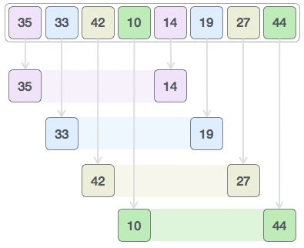

We compare values in each sub-list and swap them (if necessary) in the original array. After this step, the new array should look like this −

Shell Sort

Then, we take interval of 1 and this gap generates two sub-lists - {14, 27, 35, 42}, {19, 10, 33, 44}

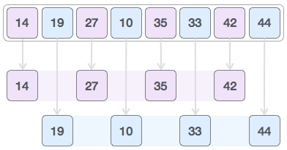

We compare and swap the values, if required, in the original array. After this step, the array should look like this −

Shell Sort

Finally, we sort the rest of the array using interval of value 1. Shell sort uses insertion sort to sort the array.

Following is the step-by-step depiction −

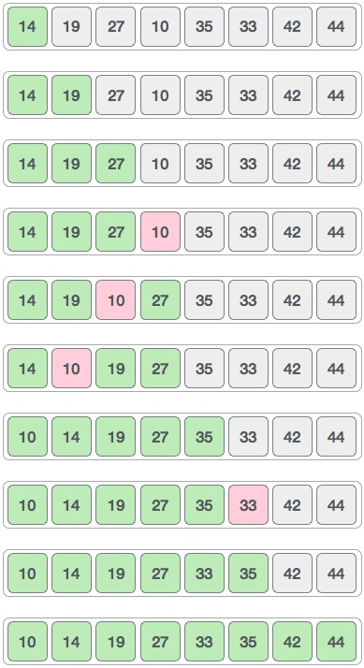

We see that it required only four swaps to sort the rest of the array.

Algorithm

Following is the algorithm for shell sort.

**Step 1** − Initialize the value of *h*

**Step 2** − Divide the list into smaller sub-list of equal interval *h*

**Step 3** − Sort these sub-lists using **insertion sort**

**Step 3** − Repeat until complete list is sorted

Pseudocode

Following is the pseudocode for shell sort.

procedure shellSort()

A : array of items

/* calculate interval*/

while interval < A.length /3 do:

interval = interval * 3 + 1

end while

while interval > 0 do:

for outer = interval; outer < A.length; outer ++ do:

/* select value to be inserted */

valueToInsert = A[outer]

inner = outer;

/*shift element towards right*/

while inner > interval -1 && A[inner - interval] >= valueToInsert do:

A[inner] = A[inner - interval]

inner = inner - interval

end while

/* insert the number at hole position */

A[inner] = valueToInsert

end for

/* calculate interval*/

interval = (interval -1) /3;

end while

end procedure

To know about shell sort implementation in C programming language, please [click here](https://www.tutorialspoint.com/data_structures_algorithms/shell_sort_program_in_c.htm)

s